**Addressing Table**

| **Device** | **Interface** | **IP Address / Prefix** | **Default Gateway** |
| --- | --- | --- | --- |
| R1 | G0/0/0 | 64.100.0.2 /30 | N/A |
| 2001:db8:acad::2 /64 |
| fe80::2 |
| G0/0/1 | 192.168.1.1 /24 |
| 2001:db8:acad:1::1 /64 |
| fe80::1 |
| ISP | G0/0/0 | 64.100.0.1 /30 | N/A |
| 2001:db8:acad::1 /64 |
| fe80::1 |
| G0/0/1 | 209.165.200.225 /27 |
| 2001:db8:acad:200::225 /64 |
| fe80::225 |
| S1 | VLAN 1 | 192.168.1.2 /24 | 192.168.1.1 |
| 2001:db8:acad:1::2 /64 | fe80::1 |
| fe80::2 |
| PC-A | NIC | 2001:db8:acad:1::10 /64 | fe80::1 |
| 192.168.1.10 /24 | 192.168.1.1 |
| External | NIC | 209.165.200.226 /27 | 209.165.200.225 |
| 2001:db8:acad:200::226 /64 | fe80::225 |

**Part 1**

**Step 1**

1. **IPv4**

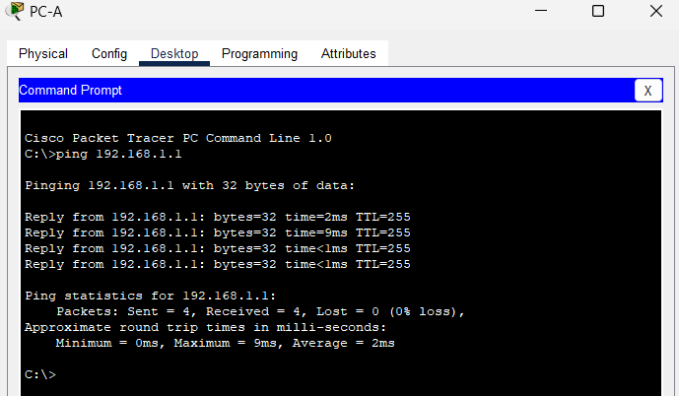

**IPv6**

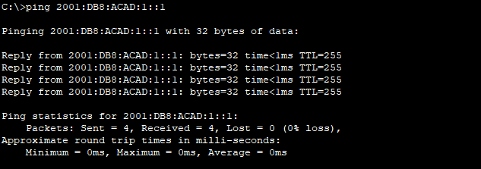

| **Destination** | **Average Round Trip Time (ms)** | **TTL / Hop Limit** |
| --- | --- | --- |
| 192.168.1.10 | <1ms | 128 |
| 2001:db8:acad:1::10 | <1ms | 128 |
| 192.168.1.1 (R1) | <1ms | 255 |
| 2001:db8:acad:1::1 (R1) | 1ms | 255 |
| 192.168.1.2 (S1) | 1ms | 255 |
| 2001:db8:acad:1::2(S1) | 1ms | 255 |
| 64.100.0.2 (R1) | 1ms | 255 |
| 2001:db8:acad::2 (R1) | <1ms | 255 |
| 64.100.0.1 (ISP) | <1ms | 254 |
| 2001:db8:acad::1 (ISP) | 1ms | 254 |
| 209.165.200.225 (ISP G0/0/1) | Unreachable | Unreachable |
| 2001:db8:acad:200::225 (ISP G0/0/1) | Unreachable | Unreachable |
| 209.165.200.226 (External) | Unreachable | Unreachable |
| 2001:db8:acad:200::226 (External) | Unreachable | Unreachable |

**Step 2**

What are the ping results from S1 to ISP and External?  
**The pings were successful to ISP G0/0/0 interface. The pings were unsuccessful to ISP G0/0/1 interface and External NIC.**

**Part 2**

**Step 1**

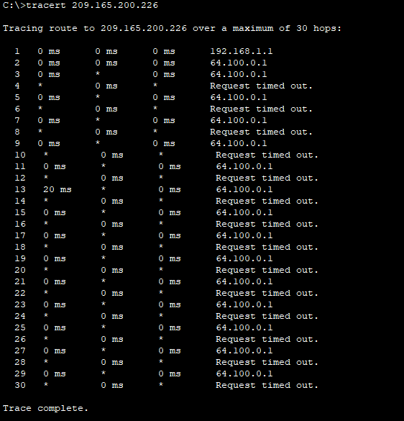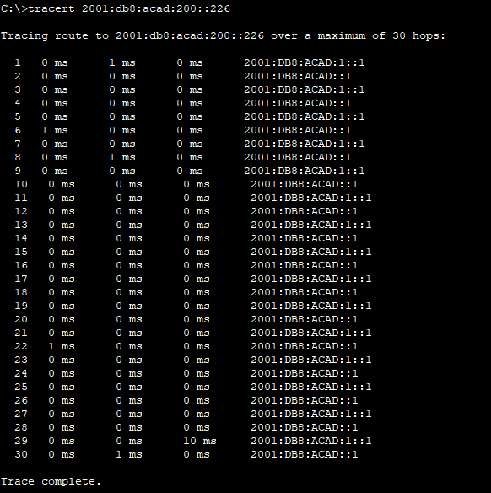

**Step 2**

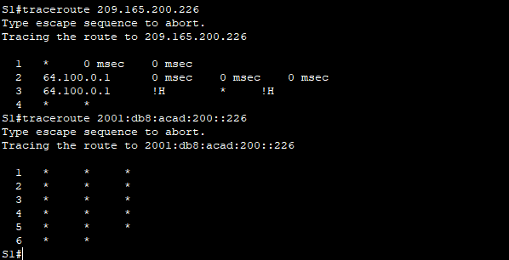

**Part 3**

**Step 1**



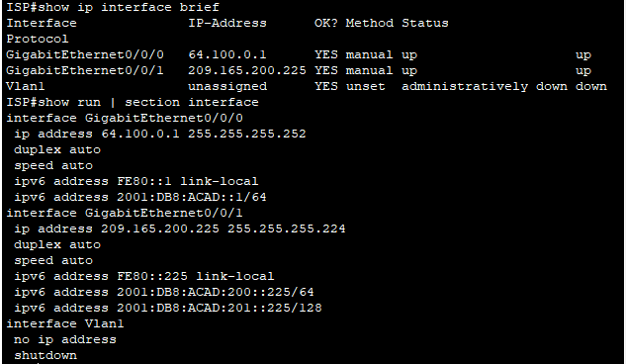

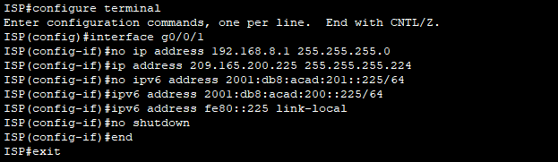

**Step 2**

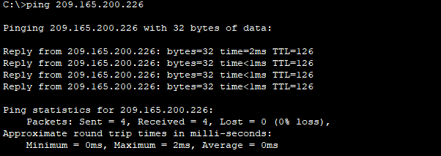

**Part 4**

**Step 1**

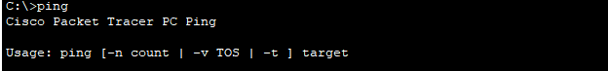

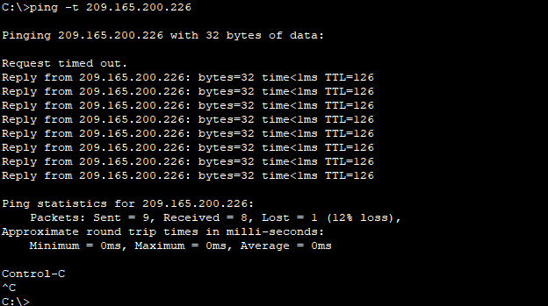



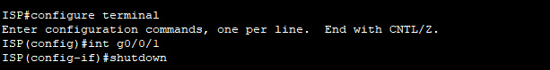

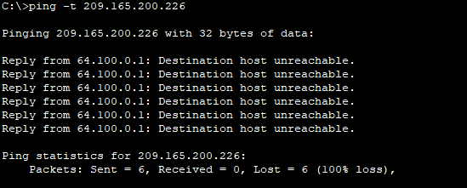



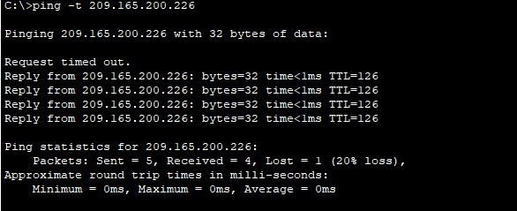

What ICMP error messages did you receive?  
**Destination net unreachable, request timed out.**

**Step 2**

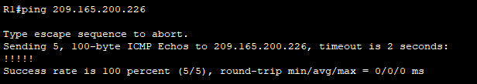

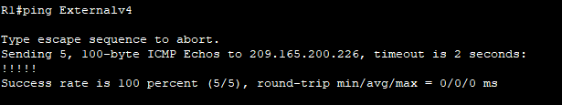

What is the IP address used?  
**209.165.200.226**

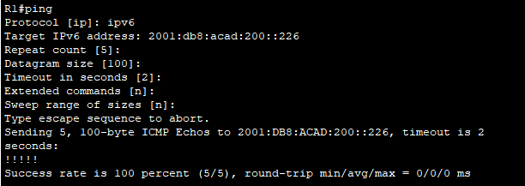

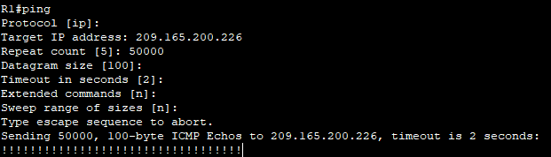

**Reflection Questions**

1. What could prevent ping or traceroute responses from reaching the originating device beside network connectivity issues?  
**Firewall on the PCs, access list commands, routing issues, interface is down, network delay**

2. If you ping a non-existent address on the remote network, such as 209.165.200.227, what is the message displayed by the **ping** command? What does this mean? If you ping a valid host address and receive this response, what should you check?  
**Request timed out or periods (.). This means that there was no response in the default time period. Some of the items you may check: router is down, destination host is down, return route to your device and latency of the response is not more than the default time period**

3. If you ping an address that does not exist in any network in your topology, such as 192.168.5.3, from a Windows-based PC, what is the message displayed by the **ping** command? What does this message indicate?  
**Destination host unreachable. This message indicates that there is no route to the destination as the network is not listed by the routing table.**